Database Design and Development Report
Date | 27th JUNE 2025
Team ID | LTVIP2025TMID47711
Project Name | HouseHunt – House Rent Web Application

Project Title: HouseHunt – House Rent Web Application

Date: 27th JUNE 2025

Objective
The objective of this report is to outline the database design and implementation details for the HouseHunt – House Rent Web Application project, including schema design and database management system (DBMS) integration.

Technologies Used
- Database Management System (DBMS): MongoDB
- Object-Document Mapper (ODM): Mongoose

Design the Database Schema
The database schema is designed to accommodate the following entities and relationships:

1. Users
- Attributes:
- _id: ObjectId
- name: String
- email: String (unique)
- password: String
- createdAt: Date
- updatedAt: Date

2. Properties
- Attributes:
- _id: ObjectId
- title: String
- description: String
- location: String
- price: Number
- owner: ObjectId (references User)
- createdAt: Date
- updatedAt: Date

3. Bookings
- Attributes:
- _id: ObjectId
- property: ObjectId (references Property)
- user: ObjectId (references User)
- bookingDate: Date
- createdAt: Date
- updatedAt: Date

Implement the Database using MongoDB
The MongoDB database is implemented with the following collections and structures:
Database Name: [your_database_name]

1. Collection: users
- Schema:
```
{
_id: ObjectId
name: String
email: String (unique)
password: String
createdAt: Date
updatedAt: Date
}
```

2. Collection: properties
- Schema:
```
{
_id: ObjectId
title: String
description: String
location: String
price: Number
owner: ObjectId (references User)
createdAt: Date
updatedAt: Date
}
```

3. Collection: bookings
- Schema:
```
{
_id: ObjectId
property: ObjectId (references Property)
user: ObjectId (references User)
bookingDate: Date
createdAt: Date
updatedAt: Date
}
```

Integration with Backend
- Database connection:
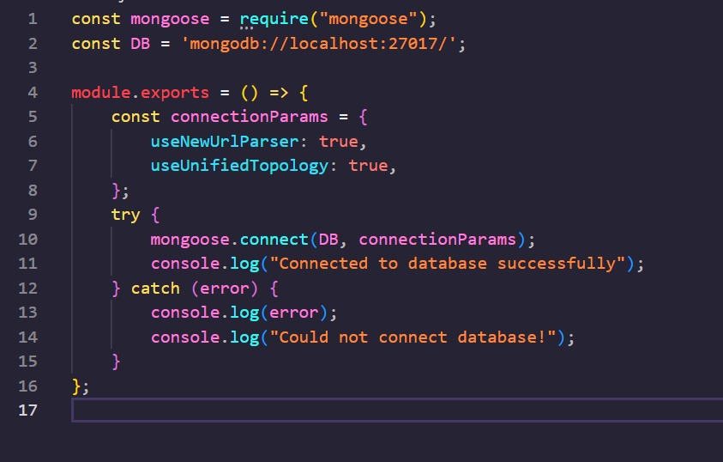

- The backend APIs interact with MongoDB using Mongoose ODM Key interactions include:
  - User Management: CRUD operations for users.
  - Posting Management: CRUD operations for posting properties with user authentication.
Booking Management: CRUD operations for booking properties.

